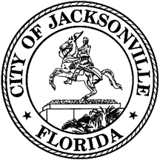

City Council Page

Application Request Form
The Jacksonville City Council Page Program seeks to give youth between the ages of 10 through 18 the opportunity to learn about the inner workings of local government and gain valuable experience. The Pages will work for before and during a City Council meeting and help with tasks assigned by the Legislative Services Division.
Please fill out the form below to have a youth participate in the City Council Page Program. For any questions, please contact Merriane Lahmeur, Chief of Legislative Services at MGLahmeur@coj.net or (904) 255-5122.Please note that an Adult/Guardian/Parent is required to accompany the youth participant to the Council meeting.
Requesting Council Member *

Student Name *

Contact Person *

First Name * Last Name *

Contact Phone *

Contact Email *

Requested Meeting Date *

Grade Level of Student and School *

Photo Approval (to take picture and post) Yes or No *

Additional Notes

(Special requests, accommodations needed, medical needs or allergies, etc.)

Acknowledgment that an Adult/Parent/Guardian is required to accompany the participant to the Council meeting and remain until the conclusion of participation. The Page is requested to participate in the program from 4:00 pm to 7:15 pm.

Initials

