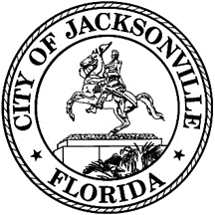

City Council Group Tour

Application Request Form
The Jacksonville City Council Group Tour Program seeks to give youth of every age the opportunity to learn about the inner workings of local government and gain valuable experience. Students participating in the program will receive a special guided tour of City Hall, participate in mock ordinance activities, and meet with a City Council member(s) and staff.
Please fill out the form below to have your group participate in the City Council Group Tour. For any questions, please contact Merriane Lahmeur, Chief of Legislative Services at MGLahmeur@coj.net or (904) 255-5122.Please note that chaperones are required to accompany the youth for the tour.
Group Name *

Contact Person *

First Name * Last Name *

Contact Phone *

Contact Email *

Requested Tour Date *

Requested Tour Time *

Grade Level of Guests

(Special requests, accommodations needed, medical needs or allergies, etc.)

Acknowledgment that a chaperone(s) is required to accompany the participants to the Council Group Tour and remain until the conclusion of participation.
Initials

