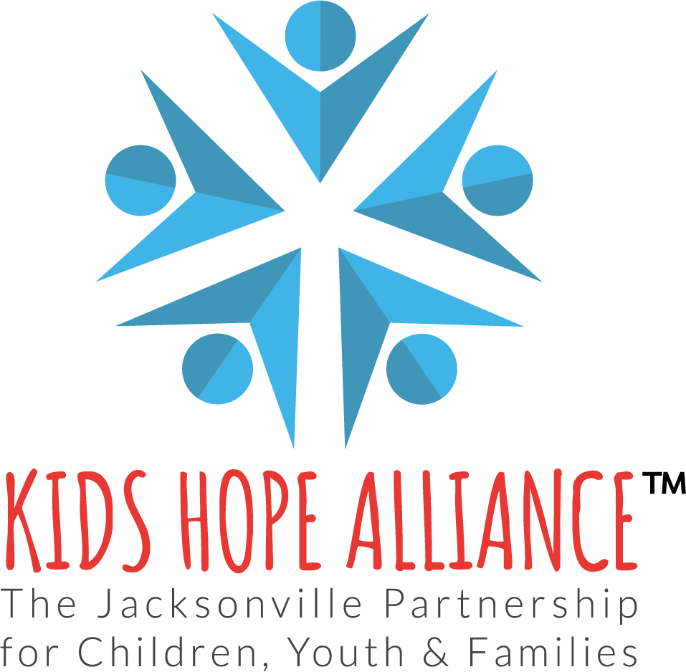
PUBLIC NOTICE
KIDS HOPE ALLIANCE
GOVERNANCE AND PROGRAMS COMMITTEE MEETING
IN-PERSON MEETING NOTICE
November 27, 2023, 10:00 a.m.

Notice is hereby given that the Kids Hope Alliance Governance and Programs Committee meeting will meet in-person on November 27, 2023 at 10:00 a.m. This meeting is offered in-person at the Kids Hope Alliance Board Room and the agenda will be available 48 hours before the meeting.

PHYSICAL LOCATION
November 27, 2023 at 10:00 a.m.
Kids Hope Alliance Board Room, 2nd Floor
1095 A. Philip Randolph Blvd.
Jacksonville, FL 32206

WEBINAR LOCATION (View Only)
https://us02web.zoom.us/j/81897291781
Persons attending this meeting in-person will be given an opportunity to provide public comment during the designated public comment period provided they fill out a blue speaker card at the meeting. Interested persons who cannot attend the meeting, but wish to submit public comments to be read during the public comment period of the meeting regarding any matter on the agenda for consideration at the meeting, may do so by emailing Deborah Sibley at SibleyD@coj.net no later than 24 hours before the start of the meeting.

Pursuant to the Americans with Disabilities Act, accommodations for persons with disabilities are available upon request. Please allow 1-2 business days notification to process; last minute requests will be accepted but may not be possible to fulfill. Please contact Disabled Services Division at: V(904) 255-5466, TTY-(904) 255-5476, or email your request to karat@coj.net.

Please contact Deborah Sibley by telephone at (904) 255-4449 or by email at SibleyD@coj.net if you have any questions regarding this notice.

